United Dioceses of Cork, Cloyne and Ross

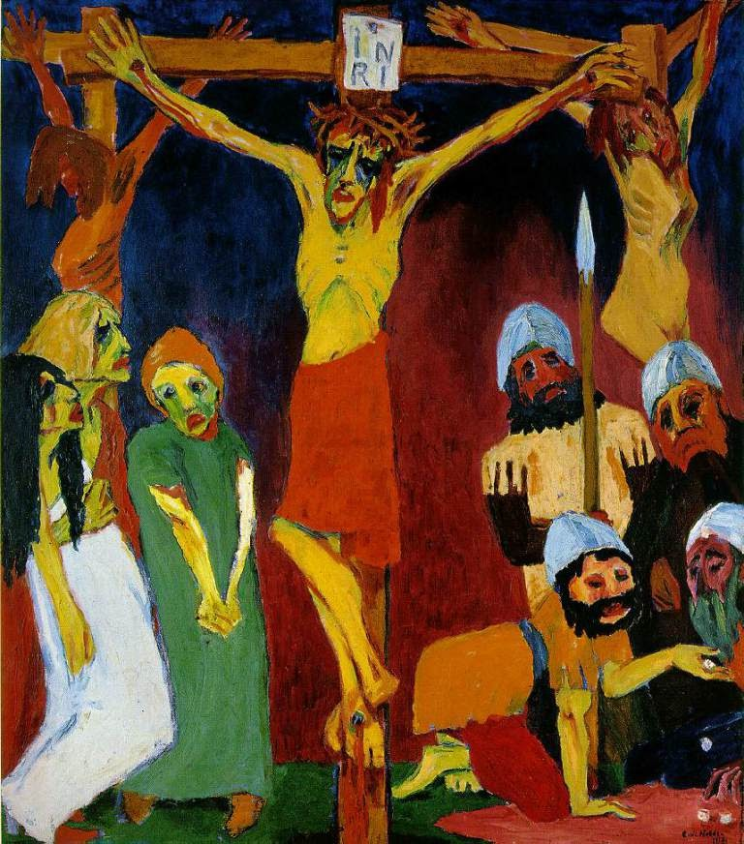

Good Friday 2020

Celebrating Good Friday

The central theme of the Good Friday Service is the cross of Jesus.
We hear again the events of this day leading to the crucifixion.

The Liturgy is stark, and leaves us with a sense of dereliction and desolation.

Some of the hymns, in contrast to usual liturgical practice, are sung while seated.

This is emphasised by not celebrating the Eucharist, by the lack of colour, and by the use of silence.

The Service is in three parts:

- Ministry of the Word
- Proclamation of the Cross and
- the Prayers of the People

[Please sit in silence and reflection as we wait for the Service to begin]

The Gathering of God’s People

Silent Prayer
All being with a time of silent prayer

The Collect of Good Friday
Almighty Father, look with mercy on this your family for which our Lord Jesus Christ was content to be betrayed and given up into the hands of sinners and to suffer death upon the cross; who is alive and glorified with you and the Holy Spirit, one God, now and forever.
Amen.

Proclaiming God’s Word

Psalm 22

R My God, my God, why have you forsaken me?

My God, my God, why have you forsaken me? and are so far from my cry and from the words of my distress? O my God, I cry in the daytime, but you do not answer; by night as well, but I find no rest.
Yet you are the Holy One, enthroned upon the praises of Israel. R

Our forebears put their trust in you; they trusted and you delivered them. They cried out to you and were delivered; they trusted in you and were not put to shame. R

But as for me, I am a worm and no man, scorned by all and despised by the people. All who see me laugh me to scorn; they curl their lips and wag their heads, saying, ‘He trusted in the Lord; let him deliver him; let him rescue him, if he delights in him.’ R

Yet you are he who took me out of the womb, and kept me safe upon my mother’s breast. I have been entrusted to you ever since I was born; you were my God when I was still in my mother’s womb. R

Be not far from me, for trouble is near, and there is none to help. Many young bulls encircle me; strong bulls of Bashan surround me. They open wide their jaws at me, like a ravening and a roaring lion. R

I am poured out like water; all my bones are out of joint; my heart within my breast is melting wax. My mouth is dried out like a pot-sherd; my tongue sticks to the roof of my mouth; and you have laid me in the dust of the grave. R

Packs of dogs close me in, and gangs of evildoers circle around me; they pierce my hands and my feet; I can count all my bones. They stare and gloat over me; they divide my garments among them; they cast lots for my clothing. R

Be not far away, O Lord; you are my strength; hasten to help me. Save me from the sword, my life from the power of the dog. Save me from the lion’s mouth, my wretched body from the horns of wild bulls. R

I will declare your name to my people; in the midst of the congregation I will praise you. Praise the Lord, you that fear him; stand in awe of him, O offspring of Israel; all you of Jacob’s line, give glory. R

For he does not despise nor abhor the poor in their poverty; neither does he hide his face from them; but when they cry to him he hears them. My praise is of him in the great assembly; I will perform my vows in the presence of those who worship him. R

The poor shall eat and be satisfied, and those who seek the Lord shall praise him: ‘May your heart live for ever!’ All the ends of the earth shall remember and turn to the Lord, and all the families of the nations shall bow before him. For kingship belongs to the Lord; he rules over the nations. R

To him alone all who sleep in the earth bow down in worship; all who go down to the dust fall before him. My soul shall live for him; my descendants shall serve him; they shall be known as the Lord’s for ever. They shall come and make known to a people yet unborn the saving deeds that he has done. R
The Passion Gospel ~ Part I: 6 a.m. to 9 a.m.

Mark 15.1-21

Silence follows the reading, then remain seated to sing

Hymn 244
There is a green hill far away,
Without a city wall,
Where the dear Lord was crucified,
Who died to save us all.

We may not know, we cannot tell
What pains he had to bear,
But we believe it was for us
He hung and suffered there.

He died that we might be forgiven,
he died to make us good,
That we might go at last to heaven,
Saved by his precious Blood.

There was no other good enough
To pay the price of sin,
He only could unlock the gate
Of heaven, and let us in.

Oh! dearly, dearly has he loved,
And we must love him too,
And trust in his redeeming Blood,
And try his works to do.

Cecil Frances (Fanny) Alexander (1818 - 1895)
Based on Mark 15.22-24

The Passion Gospel ~ Part II: 9 a.m. to Noon

Mark 15.22-32

Silence follows the reading, then remain seated to sing

Hymn 698

Jesus, Saviour of the world,
come to us in mercy.

Hear us as we pray to you,
help and heal us, Jesus.

By your cross and life laid down
you have freed your people.
Hear us …

In the greatness of your love
heal us in our weakness.
Hear us …

Saviour and Deliverer,
help us all to praise you.
Hear us …

Jesus, come and dwell with us;
hear us now and always;
Hear us …

and when you in glory come
may we share your kingdom.
Hear us …

Edward F. Darling (b. 1933)
based on the Canticle ‘Jesus Saviour of the World’

The Passion Gospel ~ Part III: Noon to 3 p.m.

Mark 15.33

Silence follows the reading

The Passion Gospel ~ Part IV: 3 p.m. to 6 p.m.

Mark 15.34-41

Silence follows the reading, then remain seated to sing

Hymn ~ Thanks and Praise 76
Jesus on the cross is dying
soon his body will be lying
in the darkness of the tomb.

God’s own mother, purest maiden,
see the sinless One sin-laden,
blessed fruit of blessed womb.

Mary’s heart for him is aching,
as she sees her Son’s heart breaking.
so that love may be revealed.

Now at last her heart is feeling
sorrow’s sword, her Son revealing
thoughts in many hearts concealed.

How could pity not awaken
for the Son of God, forsaken
in the loneliness of death?

Who would not give consolation
in this mother’s desolation
as he breathes his dying breath?

Mary’s heart for him is bleeding;
in his blood for sinners pleading,
God’s new law of love is sealed.

‘It is done’, she hears him cry
at the moment of his dying:
death by death has now been healed.

Let my heart with love be burning
for my wounded Jesus, yearning
for the vision of his face.

Let me stand beside you, sharing
grief for Jesus, my sins bearing
on the cross of Calvary.

Let me bear the wounds of Jesus,
drink the precious blood that frees us,
glory only in his cross.

Let the cross be my salvation,
Jesus’ death my consolation,
in that hour when I must die.

James Quinn, SJ (1919-2010)

The Passion Gospel ~ Part V: 6 p.m. to Burial

Mark 15.42.47

Silence

The Proclamation of the Cross
All:

A simple wooden cross is placed centrally. This proclamation is made:

The cross of Christ
The cross on which the Saviour of the world was hung.

Acclamations
We adore you, O Christ, and we bless you
because by your holy cross you have redeemed the world

This is the wood of the cross, on which hung the Saviour of the world.
Come, let us worship.

O Saviour of the world, who by your cross and precious blood have redeemed us,
save us and help us, we humbly pray.

Hymn 247
When I survey the wondrous cross
On which the Prince of Glory died,
My richest gain I count but loss,
And pour contempt on all my pride.

Forbid it, Lord, that I should boast,
Save in the Cross of Christ, my God;
All the vain things that charm me most,
I sacrifice them to his Blood.

See from his head, his hands, his feet,
Sorrow and love flow mingled down;
Did e'er such love and sorrow meet,
Or thorns compose so rich a crown?

Were the whole realm of nature mine,
that were an offering far too small;
love so amazing, so divine,
demands my soul, my life, my all.

Isaac Watts (1674 - 1748)
based on Galatians 6.14 and Philippians 3.7-8

Silence

The Prayers of The People

Father, Simon from Cyrene was forced to carry the cross for your Son. Give us the grace willingly to lift heavy loads from those we meet and to stand with those condemned to die.
Lord hear us,
Lord, graciously hear us.

Your Son watched the soldiers gamble to share his clothes. Look with forgiveness on those whose hearts are hardened by their work, and those who know not what they do.
Lord hear us,
Lord, graciously hear us.

The thief looked for the coming of the kingdom, and heard Christ say ’Today you shall be with me’. Give pardon and hope, healing and peace to all who look death in the face.
Lord hear us,
Lord, graciously hear us.

In Mary and John your Son created a new family at the cross. Fill us with your love, and give all your children a secure hope for the future.
Lord hear us,
Lord, graciously hear us.

The centurion was astonished to recognise your Son in the crucified Messiah. Open the eyes of those who do not know you to grasp in your Son the meaning of life and death.
Lord hear us,
Lord, graciously hear us.

Nicodemus came to take you Son’s body away. Give hope and faith to the dying and bereaved, gentleness to those who minister them, and courage to those whose faith is secret.
Lord hear us,
Lord, graciously hear us.

Simon and Nicodemus, Mary and John were drawn into the life of your church in Jerusalem. Bring into your Church today a varied company of people, to walk with Christ in the way of his passion, and to find your salvation in the victory of his cross.

Lord of the Church:
hear our prayer, and make us one in heart and mind to serve you with joy for ever. Amen.

Going Out as God’s People

Hymn 220
Glory be to Jesus,
who, in bitter pains,
poured for me the life-blood
from his sacred veins.

Grace and life eternal
in that blood I find:
blessed be his compassion
infinitely kind.

Abel’s blood for vengeance
pleased to the skies,
but the blood of Jesus
for our pardon cries.

When that blood is sprinkled
on our guilty hearts,
Satan in confusion
terror-struck departs.

When this earth exulting
lifts its praise on high,
angel hosts rejoicing
make their glad reply.

Raise your thankful voices,
swell the mighty flood;
louder still and louder
praise the precious blood.
Italian (c. 1815)
tr. Edward Caswall (1814-78) altd.

Standing at the foot of the cross,
let us pray with confidence as our Saviour has taught us
Our Father …

Concluding Prayer
Most merciful God,
who by the death and resurrection of your Son Jesus Christ delivered and saved humankind: grant that by faith in him who suffered on the cross, we may triumph in the power of his victory; through Jesus Christ our Lord. Amen.

The Service ends in Silence

Art on Cover

Crucifixion ~ Emil Nolde, 1912. Oil on canvas.

Copyright
Material in this service is reproduced from The Book of Common Prayer copyright © RCB 2004.

New Patterns for Worship, material from which is included in this service, is copyright © The Archbishops’ Council 2002

Common Worship: Times and Seasons, material from which is included in this service, is copyright © The Archbishops’ Council 2006

Hymns and songs subject to copyright are reproduced in accordance with Christian Copyright Licence (CCL Licence) 762859 issued to the Bishop for his exclusive use on this occasion only.

